Dr. Svetlin Nakov

Software University – <https://softuni.org>

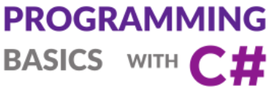

Issue 4 / 8



**More Complex Conditions**

Learn about using more complex if-else conditional statements, using switch-case, working with nested conditional statements and using more complex logical conditions with “AND”, “OR”, “NOT” and Parenthesis.

Get an idea how to build a simple Desktop GUI app  
“Point and Rectangle” in C# using Visual Studio.

# More Complex Conditions

In this mini book, we are going to examine the **nested conditional statements** in the **C#** language, by which our program can contain **conditions** that contain other **nested conditional statements**. We call them **"nested"**, because **we put an** if **condition** into **another** if **condition**. We are going to examine the **more complex logical conditions** through proper examples.

## Video: Overview

Watch this video to see what you will learn: <https://youtu.be/qvbVrKXxsu0>.

## Introduction to Complex Conditions by Examples

**Conditional statements can be nested**, i.e. we can put if-else inside another if-else statement. Conditions in the if constructions can be complex, e.g. use **logical "AND"** or **logical "OR"**. Example:

var a = decimal.Parse(Console.ReadLine());

var b = decimal.Parse(Console.ReadLine());

if (a > 0 && b > 0 && a <= 100 && b <= 100)

{

if (a * b >= 5000)

Console.WriteLine($"Large size: {a*b}");

else if (a * b > 1000 && a * b < 5000)

Console.WriteLine($"Middle size: {a * b}");

else

Console.WriteLine($"Small size: {a * b}");

}

else

Console.WriteLine($"Invalid size (a={a}, b={b})");

Run the above code example: <https://repl.it/@nakov/nested-if-else-conditions-csharp>.

The above code performs a **series of checks** using nested if-else conditional statements and logical operators like && (logical **AND**) to check the input data for the following 4 cases:

* Size out of range (one of the sides is negative or bigger than 100).
* Large size (area >= 5000).
* Middle size (1000 < area < 5000)
* Small size (area <= 1000)

Let's explain in greater detail how to use **complex and nested** if-else **conditions** in C#.

## Nested If-Else Conditions

Pretty often the program logic requires the use of if or if-else statements, which are contained one inside another. They are called **nested** if or if-else statements. As implied by the title **"nested"**, these are if or if-else statements that are placed inside other if or else statements.

if (condition1)

{

if (condition2)

{

// body;

}

else

{

// body;

}

}

### Video: Nested Conditional Statements

Watch a video lesson about the nested if-conditions: <https://youtu.be/4ugMAlkQAMo>.

### Deep Nesting

Nesting of **more than three conditional statements** inside each other is not considered a good practice and **has to be avoided**, mostly through optimization of the structure/the algorithm of the code and/or by using another type of conditional statement.

### Nested If-Else Conditions – Examples

Let's take a few examples in order to gain experience about how to use **nested if-else conditions** in practice.

### Example: Personal Titles

Depending on **age** (decimal number and **gender** (**m** / **f**), print a personal title:

* “**Mr.**” – a man (gender “**m**”) – 16 or more years old.
* “**Master**” – a boy (gender “**m**”) under 16 years.
* “**Ms.**” – a woman (gender “**f**”) – 16 or more years old.
* “**Miss**” – a girl (gender “**f**”) under 16 years.

#### Sample Input and Output

| **Input** | **Output** | **Input** | **Output** |
| --- | --- | --- | --- |
| 12 f | Miss | 17 m | Mr. |

| **Input** | **Output** | **Input** | **Output** |
| --- | --- | --- | --- |
| 25 f | Ms. | 13.5 m | Master |

#### Video: Personal Titles

Watch this video to learn how to solve this problem: <https://youtu.be/7WiBbMOAc7Q>.

#### Solution

We should notice that the **output** of the program **depends on a few things**. **First**, we have to check what is the entered **gender** and **then** check the **age**. Respectively, we are going to use **a few** **if-else** blocks. These blocks will be **nested**, meaning from **the result** of the first, we are going to **define** which one of the **others** to execute.

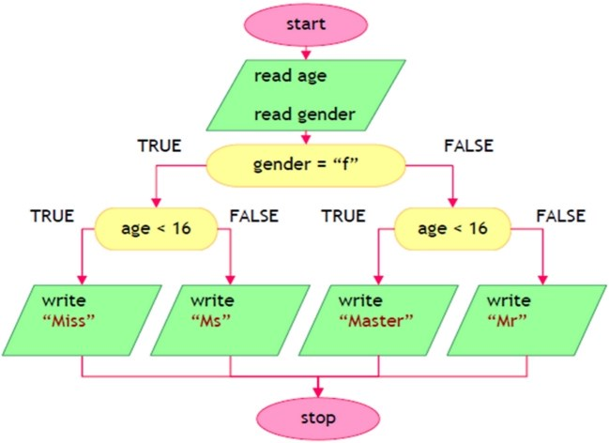

After reading the input data from the console, the following program logic should be executed:

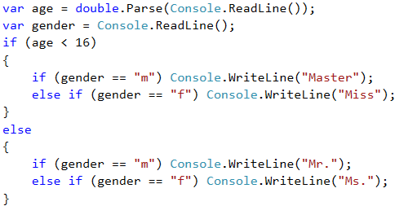

#### Testing in the Judge System

Test your solution here: <https://judge.softuni.org/Contests/Practice/Index/508#0>.

### Example: Small Shop

A Bulgarian entrepreneur opens **small shops** in **a few cities** with different **prices** for the following **products**:

| **product / city** | **Sofia** | **Plovdiv** | **Varna** |
| --- | --- | --- | --- |
| coffee water beer sweets peanuts | 0.50 0.80 1.20 1.45 1.60 | 0.40 0.70 1.15 1.30 1.50 | 0.45 0.70 1.10 1.35 1.55 |

Calculate the price by the given **city** (string), **product** (string) and **quantity** (decimal number).

#### Sample Input and Output

| **Input** | **Output** | **Input** | **Output** |
| --- | --- | --- | --- |
| coffee Varna 2 | 0.9 | peanuts Plovdiv 1 | 1.5 |

#### Video: Small Shop

Watch this video to learn how to solve this problem: <https://youtu.be/kU_ru7GK-Mg>.

#### Solution

We **convert** all of the letters into **lower register** using the function **.ToLower()**, in order to compare products and cities **no matter** what the letters are – small or capital ones.

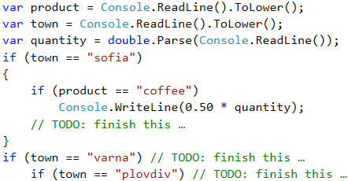

#### Testing in the Judge System

Test your solution here: <https://judge.softuni.org/Contests/Practice/Index/508#1>.

## More Complex Conditions

Let's take a look at how we can create more **complex logical conditions** in programming. We can use the logical "**AND**" (&&), logical "**OR**" (||), logical **negation** (!) and **brackets** (()).

### Logical "AND", "OR" and "NOT"

This is a short example that demonstrates the power of logical "**AND**", logical "**OR**" and logical "**NOT**":

var animal = "horse";

int speed = 45;

if ((animal == "horse" || animal == "donkey") && (speed > 40))

Console.WriteLine("Run fast")

else if ((animal == "shark" || animal == "dolphin") && (speed > 45))

Console.WriteLine("Swim fast")

else if (!(speed > 30 || animal == "turtle"))

Console.WriteLine("Slow move")

We shall explain the logical **AND** (||), the logical **OR** (||), and the logical **NOT** (!) in the next few sections, along with examples and exercises.

### The Parenthesis () Operator

Like the rest of the operators in programming, the operators && and || have a priority, as in the case && is with higher priority than ||. The operator () serves for **changing the priority of operators** and is being calculated first, just like in mathematics. Using parentheses also gives the code better readability and is considered a good practice.

Example of checking whether a variable belongs to certain ranges:

if (x < 0) || ((x >= 5) && (x <= 10)) || (x > 20)

{

...

}

## Logical "AND"

As we saw, in some tasks we have to make **many checks at once**. But what happens when in order to execute some code **more** conditions have to be executed and we **don't want to** make a **negation** (**else**) for each one of them? The option with nested **if blocks** is valid, but the code would look very **unordered** and for sure – **hard** to read and maintain.

The logical "**AND**" (operator **&&**) means a few conditions have to be **fulfilled simultaneously**. The following table of truthfulness is applicable:

| **a** | **b** | **a && b** |
| --- | --- | --- |
| true true false false | true false true false | true false false false |

### Video: Logical "AND"

Watch this video to learn how to use logical "AND" in programming: <https://youtu.be/V86_z8GWarM>.

### How the && Operator Works?

The **&&** operator accepts **a couple of Boolean** (conditional) statements, which have a **true** or **false** value, and returns **one** bool statement as a **result**. Using it **instead** of a couple of nested **if** blocks, makes the code **more readable**, **ordered** and **easy** to maintain. But how does it **work**, when we put a **few** conditions one after another? As we saw above, the logical **"AND"** returns **true**, **only** when it accepts as **arguments statements** with value **true**. Respectively, when we have a **sequence** of arguments, the logical "AND" **checks** either until one of the arguments is **over**, or until it **meets** an argument with value **false**.

**Example**:

bool a = true;

bool b = true;

bool c = false;

bool d = true;

bool result = a && b && c && d;

// false (as d is not being checked)

The program will run in the **following** way: **It starts** the check form **a**, **reads** it and accepts that it has a **true** value, after which it **checks** **b**. After it has **accepted** that **a** and **b** return **true**, **it checks the next** argument. It gets to **c** and sees that the variable has a **false** value. After the program accepts that the argument **c** has a **false** value, it calculates the expression **before c**, **independent** of what the value of **d** is. That is why the evaluation of **d** is being **skipped** and the whole expression is calculated as **false**.

https://csharp-book.softuni.org/assets/chapter-4-images/00.Logical-and-01.png

### Example: Point in a Rectangle

Checks whether **point {x, y}** is placed **inside the rectangle {x1, y1} – {x2, y2}**. The input data is read from the console and consists of 6 lines: the decimal numbers **x1**, **y1**, **x2**, **y2**, **x** and **y** (as it is guaranteed that **x1 < x2** and **y1 < y2**).

#### Sample Input and Output

| **Input** | **Output** | **Visualization** |
| --- | --- | --- |
| 2 -3 12 3 8 -1 | Inside | shop |

#### Solution

A point is internal for a given polygon, if the following four conditions are applied **at the same time**:

* The point is placed to the right from the left side of the rectangle.
* The point is placed to the left from the right side of the rectangle.
* The point is placed downwards from the upper side of the rectangle.
* The point is placed upwards from the down side of the rectangle.

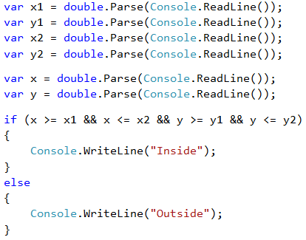

#### Testing in the Judge System

Test your solution here: <https://judge.softuni.org/Contests/Practice/Index/508#2>.

## Logical "OR"

The logical **"OR"** (operator **||**) means that **at least one** among a few conditions is fulfilled. Similar to the operator **&&**, the logical **"OR"** accepts a few arguments of **bool** (conditional) type and returns **true** or **false**. We can easily guess that we **obtain** a value **true** every time when at least **one** of the arguments has a **true** value. Typical example of the logic of this operator is the following:

At school the teacher says: "John or Peter should clean the board". To fulfill this condition (to clean the board), it is possible either just for John to clean it, or just for Peter to clean it, or both of them to do it.

| **a** | **b** | **a || b** |
| --- | --- | --- |
| true true false false | true false true false | true true true false |

### Video: Logical "OR"

Watch this video to learn how to use logical "OR" in programming: <https://youtu.be/e6i-2E66RNU>.

### How the || Operator Works?

We have already learned what the logical **"OR" represents**. But how is it actually being achieved? Just like with the logical **"AND"**, the program **checks** from left to right **the arguments** that are given. In order to obtain **true** from the expression, it is necessary for **just one** argument to have a **true** value. Respectively, the checking **continues** until an **argument** with **such** value is met or until the arguments **are over**.

Here is one **example** of the **||** operator in action:

bool a = false;

bool b = true;

bool c = false;

bool d = true;

bool result = a || b || c || d;

// true (as c and d are not being checked)

The programs **checks a**, accepts that it has a value **false** and continues. Reaching **b**, it understands that it has a **true** value and the whole **expression** is calculated as **true**, **without** having to check **c** or **d**, because their values **wouldn't change** the result of the expression.

### Example: Fruit or Vegetable

Let's check whether a given **product** is **a fruit** or **a vegetable**. The "**fruits**" are: **banana**, **apple**, **kiwi**, **cherry**, **lemon** and **grapes**. The "**vegetables**" are: **tomato**, **cucumber**, **pepper** and **carrot**. Everything else is "**unknown**".

#### Sample Input and Output

| **Input** | **Output** |
| --- | --- |
| banana tomato java | fruit vegetable unknown |

#### Solution

We have to use a few conditional statements with logical "**OR**" (**||**):

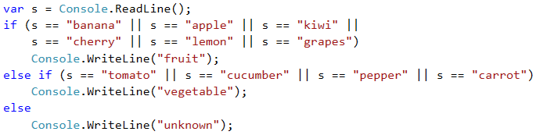

#### Testing in the Judge System

Test your solution here: <https://judge.softuni.org/Contests/Practice/Index/508#3>.

## Logical Negation (NOT)

**Logical negation** (operator !) means a given condition is **not fulfilled**.

| **a** | **!a** |
| --- | --- |
| true | false |

The operator ! accepts as an **argument** a bool variable and **returns** its value.

### Video: Logical "NOT"

Watch this video to learn how to use the **logical "NOT"** operator in programming: <https://youtu.be/4U7w2ZSAAW4>.

### Example: Invalid Number

A given **number is valid** if it is in the range [**100 … 200**] or it is **0**. Do a validation for an **invalid** number.

#### Sample Input and Output

| **Input** | **Output** |
| --- | --- |
| 75 | invalid |
| 150 | (no output) |
| 220 | invalid |

#### Solution

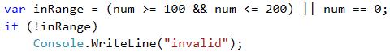

#### Testing in the Judge System

Test your solution here: <https://judge.softuni.org/Contests/Practice/Index/508#4>.

## More Complex Conditions – Examples

Sometimes the conditions may be **very complex**, so they can require a long bool expression or a sequence of conditions. Let's take a look at a few examples.

### Example: Point on a Rectangle Side

Write a program that checks whether a **point {x, y}** is placed **onto any of the sides of a rectangle {x1, y1} – {x2, y2}**. The input data is read from the console and consists of 6 lines: the decimal numbers **x1**, **y1**, **x2**, **y2**, **x** and **y** (as it is guaranteed that **x1 < x2** and **y1 < y2**). Print "**Border**" (if the point lies on any of the sides) or "**Inside / Outside**" (in the opposite case).

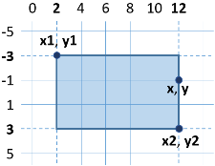

#### Sample Input and Output

| **Input** | **Output** | **Input** | **Output** |
| --- | --- | --- | --- |
| 2 -3 12 3 12 -1 | Border | 2 -3 12 3 8 -1 | Inside / Outside |

#### Solution

The point lies on any of the sides of the rectangle if:

* **x** coincides with **x1** or **x2** and at the same time **y** is between **y1** and **y2** or
* **y** coincides with **y1** or **y2** and at the same time **x** is between **x1** and **x2**.

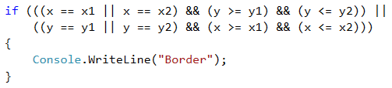

The previous evaluation might be simplified in the following way:

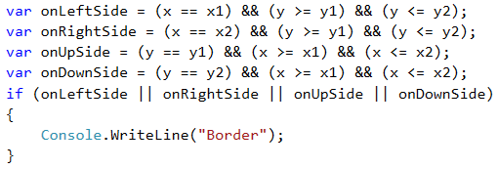

The second way with the additional Boolean (bool) variables is longer, but much more understandable than the first one, isn't it? We recommend when you write Boolean conditions to make them **easy to read and understand**, instead of making them short. Use additional variables with meaningful names, if needed. The names of the bool variables have to hint what the value that is kept inside them represents.

What remains is to finish writing the code to print “**Inside / Outside**”, if the point is not onto any of the sides of the rectangle.

#### Testing in the Judge System

After you finish writing the solution, you can test it here, in the judge system: <https://judge.softuni.org/Contests/Practice/Index/508#5>.

### Example: Fruit Shop

A fruit shop during **week days** sells in the following **prices**:

| **Fruit** | **Price** |
| --- | --- |
| banana apple orange grapefruit kiwi pineapple grapes | 2.50 1.20 0.85 1.45 2.70 5.50 3.85 |

During the weekend days the prices are **higher**:

| **Fruit** | **Price** |
| --- | --- |
| banana apple orange grapefruit kiwi pineapple grapes | 2.70 1.25 0.90 1.60 3.00 5.60 4.20 |

Write a program that **reads** from the console a **fruit** (banana / apple / …), **a day of the week** (Monday / Tuesday / …) and **a quantity (a decimal number)** and **calculates the price** according to the prices from the tables above. The result has to be printed **rounded up to 2 digits after the decimal point**. Print **“error”** if it is an **invalid day** of the week or an **invalid name** of a fruit.

#### Sample Input and Output

| **Input** | **Output** | **Input** | **Output** |
| --- | --- | --- | --- |
| orange Sunday 3 | 2.70 | kiwi Monday 2.5 | 6.75 |

| **Input** | **Output** | **Input** | **Output** |
| --- | --- | --- | --- |
| grapes Saturday 0.5 | 2.10 | tomato Monday 0.5 | error |

#### Video: Fruit Store

Watch the video to learn how to solve the "Fruit Store" problem: <https://youtu.be/6vZZzil9xBU>.

#### Solution

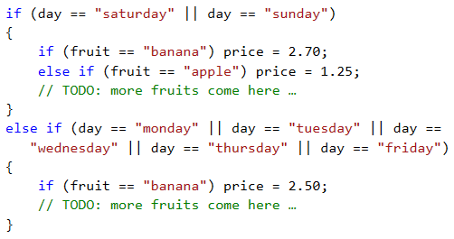



#### Testing in the Judge System

Test your solution here: <https://judge.softuni.org/Contests/Practice/Index/508#6>.

### Example: Trade Fees

A company is giving the following **commissions** to its traders according to the **city**, in which they are working and the **volume of sales s**:

| **City** | **0 <= s <= 500** | **500 < s <= 1000** | **1000 < s <= 10000** | **s > 10000** |
| --- | --- | --- | --- | --- |
| Sofia Varna Plovdiv | 5% 4.5% 5.5% | 7% 7.5% 8% | 8% 10% 12% | 12% 13% 14.5% |

Write a **program** that reads the name of a **city** (string) and the volume of **sales** (decimal number) and calculates the rate of the commission fee. The result has to be shown rounded **up to 2 digits after the decimal point**. When there is an **invalid city or volume of sales** (a negative number), print "**error**".

#### Sample Input and Output

| **Input** | **Output** | **Input** | **Output** | **Input** | **Output** |
| --- | --- | --- | --- | --- | --- |
| Sofia 1500 | 120.00 | Plovdiv 499.99 | 27.50 | Paris -50 | error |

#### Video: Trade Fees

Watch the video about the "Trade Fees" problem and its solution: <https://youtu.be/QqKBLJ4JzJ0>.

#### Solution

When reading the input, we could convert the city into small letters (with the function **.ToLower()**). Initially we set the commission fee to **-1**. It will be changed if the city and the price range are found in the table of commissions. To calculate the commission according to the city and volume of sales, we need a few nested **if statements**, as in the sample code below:

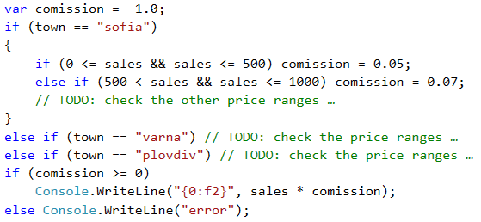

#### Testing in the Judge System

Test your solution here: <https://judge.softuni.org/Contests/Practice/Index/508#7>.

|  |  |
| --- | --- |
| https://csharp-book.softuni.org/assets/alert-icon.png | **It is a good practice** to use **blocks** that are **enclosed** with curly braces **{ }** after **if** and **else**. Also, it is recommended during writing to **move aside** the code **after if and else** with a single tabulation **inward**, in order to make the code more easily readable. |

## Switch-Case Conditional Statement

The **switch-case** condition works as a sequence of **if-else** blocks. Whenever the work of our program depends on the value of **one variable**, instead of making consecutive conditions with **if-else** blocks, we can **use** the conditional **switch** statement. It is being used for **choosing between a list of possibilities**. The statement compares a given value with defined constants and depending on the result, it takes an action.

We put **the variable** that we want to **compare**, inside the **brackets after the operator switch** and it is called a "**selector**". Here **the type must be comparable** (numbers, strings). **Consecutively**, the program starts **comparing** each **value** that **is found** after the **case labels**. Upon a match, the execution of the code from the respective place begins and continues until it reaches the operator **break**. In some programming languages (like C and C++) **break** might be skipped, in order to execute a code from other **case** construction, until it reaches another operator. In C# though, the presence of **break** is **mandatory** for **every case** that contains a program logic. When **no matches** are **found**, the **default** construction is being executed, **if** such **exists**.

switch (selector)

{

case value1:

construction;

break;

case value2:

construction;

break;

case value3:

construction;

break;

…

default:

construction;

break;

}

### Video: Switch-Case

Watch the video to learn how to use the switch-case conditional statement: <https://youtu.be/mGJOc4xx5Ho>.

### Example: Day of the Week

Let's write a program that prints **the day of the week** (in English) depending on the **given number** (1 … 7) or "**Error!**" if an invalid input is given.

#### Sample Input and Output

| **Input** | **Output** |
| --- | --- |
| 1 7 -1 | Monday Sunday Error! |

#### Solution

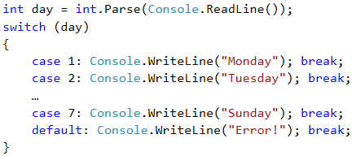

|  |  |
| --- | --- |
| https://csharp-book.softuni.org/assets/alert-icon.png | **It is a good practice** to put at the **first** place those **case statements** that process **the most common situations** and leave the **case constructions** processing **the more rear situations** at **the end, before the default construction**. Another **good practice** is to **arrange the case labels** in **ascending order**, regardless of whether they are integral or symbolic. |

#### Testing in the Judge System

Test your solution here: <https://judge.softuni.org/Contests/Practice/Index/508#8>.

### Multiple Switch-Cases

In **C#** we have the possibility to **use multiple case** labels, when they have to execute **the same code**. This way, when our **program** finds a **match**, it will execute the **next** code, because **after** the respective **case** label **there is no code** for execution and a **break** operator.

switch (selector)

{

case value1:

case value2:

case value3:

construction;

break;

case value4:

case value5:

construction;

break;

…

default:

construction;

break;

}

### Example: Animal Type

Write a program that prints the type of the animal depending on its name:

* dog -> **mammal**
* crocodile, tortoise, snake -> **reptile**
* others -> **unknown**

#### Sample Input and Output

| **Input** | **Output** | **Input** | **Output** | **Input** | **Output** |
| --- | --- | --- | --- | --- | --- |
| tortoise | reptile | dog | mammal | elephant | unknown |

#### Solution

We can solve the task with **switch**-**case** conditions with multiple labels in the following way:

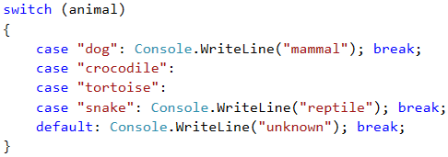

#### Testing in the Judge System

Test your solution here: <https://judge.softuni.org/Contests/Practice/Index/508#9>.

## Exercises: More Complex Conditions

Now let's **exercise** our new skills with **complex conditions**. Let's solve a few practical tasks.

### Video: Summary

Watch this video to review what we learned: <https://youtu.be/QOhyJXZ0HHQ>.

### What We Learned?

Before proceeding ahead, let's remind ourselves about the new program constructs and techniques that we have learned.

#### Nested Conditions

if (condition1)

{

if (condition2)

// body;

else

// body;

}

#### Complex Conditions with &&, ||, ! and ()

if ((x == left || x == right) && y >= top && y <= bottom)

Console.WriteLine(…);

#### Switch-Case Conditions

switch (selector)

{

case value1:

construction;

break;

case value2:

case value3:

construction;

break;

…

default:

construction;

break;

}

### Problem: Cinema

In a cinema hall the chairs are ordered in a **rectangle** shape in **r** rows and **c** columns. There are three types of screenings with tickets of **different** prices:

* **Premiere** – a premiere screening, with price **12.00** levs.
* **Normal** – a standard screening, with price **7.50** levs.
* **Discount** – a screening for children and students on a reduced price – **5.00** levs.

Write a program that enters a **type of screening** (string), number of **rows** and number of **columns** in the hall (integer numbers) and calculates **the total income** from tickets from a **full hall**. The result has to be printed in the same format as in the examples below – rounded up to 2 digits after the decimal point.

#### Sample Input and Output

| **Input** | **Output** | **Input** | **Output** |
| --- | --- | --- | --- |
| Premiere 10 12 | 1440.00 leva | Normal 21 13 | 2047.50 leva |

#### Hints and Guidelines

While reading the input, we could convert the screening type into small letters (with the function **.ToLower()**). We create and initialize a variable that will store the calculated income. In another variable we calculate the full capacity of the hall. We use a **switch-case** conditional statement to calculate the income according to the type of the projection and print the result on the console in the given format (look for the needed **C#** functionality on the internet).

Sample code (parts of the code are blurred with the purpose to stimulate your thinking and solving skills):

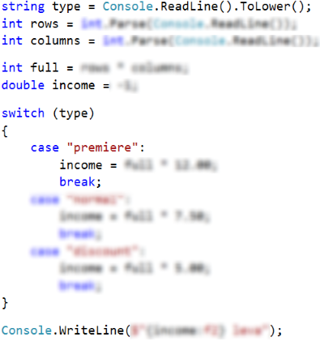

#### Testing in the Judge System

Test your solution here: <https://judge.softuni.org/Contests/Practice/Index/508#10>.

### Problem: Volleyball

Vladimir is a student, lives in Sofia and goes to his hometown from time to time. He is very keen on volleyball, but is busy during weekdays and plays **volleyball** only during **weekends** and on **holidays**. Vladimir plays **in Sofia** every **Saturday**, when **he is not working**, and **he is not traveling to his hometown** and also during **2/3 of the holidays**. He travels to his **hometown h times** a year, where he plays volleyball with his old friends on **Sunday**. Vladimir **is not working 3/4 of the weekends**, during which he is in Sofia. Furthermore, during **leap years** Vladimir plays **15% more** volleyball than usual. We accept that the year has exactly **48 weekends**, suitable for volleyball. Write a program that calculates **how many times Vladimir has played volleyball** through the year. **Round the result** down to the nearest whole number (e.g. 2.15 -> 2; 9.95 -> 9).

The input data is read from the console:

* The first line contains the word “**leap**” (leap year) or “**normal**” (a normal year with 365 days).
* The second line contains the integer **p** – the count of holidays in the year (which are not Saturday or Sunday).
* The third line contains the integer **h** – the count of weekends, in which Vladimir travels to his hometown.

#### Sample Input and Output

| **Input** | **Output** | **Input** | **Output** |
| --- | --- | --- | --- |
| leap 5 2 | 45 | normal 3 2 | 38 |

| **Input** | **Output** | **Input** | **Output** |
| --- | --- | --- | --- |
| normal 11 6 | 44 | leap 0 1 | 41 |

#### Hints and Guidelines

As usual, we read the input data from the console and, to avoid making mistakes, we convert the text into small letters with the function **.ToLower()**. Consequently, we calculate **the weekends spent in Sofia**, **the time for playing in Sofia** and **the common playtime**. At last, we check whether the year is **leap**, we make additional calculation when necessary and we print the result on the console **rounded down** to the nearest **integer** (look for a **C#** class with such functionality).

A sample code (parts of the code are blurred on purpose to stimulate independent thinking and solving skills):

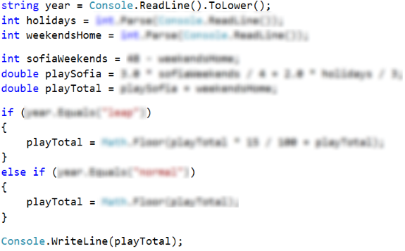

#### Testing in the Judge System

Test your solution here: <https://judge.softuni.org/Contests/Practice/Index/508#11>.

### Problem: * Point in the Figure

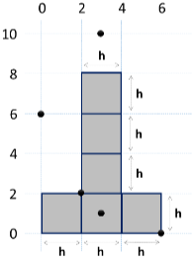The figure consists of **6 blocks with size h * h**, placed as in the figure below. The lower left angle of the building is on position {0, 0}. The upper right angle of the figure is on position {**2*h**, **4*h**}. The coordinates given in the figure are for **h = 2**:

Write a program that enters an integer **h** and the coordinates of a given **point {x, y}** (integers) and prints whether the point is inside the figure (**inside**), outside of the figure (**outside**) or on any of the borders of the figure (**border**).

#### Sample Input and Output

| **Input** | **Output** | **Input** | **Output** |
| --- | --- | --- | --- |
| 2 3 10 | outside | 2 3 1 | inside |

| **Input** | **Output** | **Input** | **Output** |
| --- | --- | --- | --- |
| 2 2 2 | border | 2 6 0 | border |

| **Input** | **Output** | **Input** | **Output** |
| --- | --- | --- | --- |
| 2 0 6 | outside | 15 13 55 | outside |

| **Input** | **Output** | **Input** | **Output** |
| --- | --- | --- | --- |
| 15 29 37 | inside | 15 37 18 | outside |

| **Input** | **Output** | **Input** | **Output** |
| --- | --- | --- | --- |
| 15 -4 7 | outside | 15 30 0 | border |

#### https://csharp-book.softuni.org/assets/chapter-4-images/13.Point-in-the-figure-03.pngHints and Guidelines

A possible logic for solving the task (not the only correct one):

* We might split the figure into **two rectangles** with a common side:
* A point is **outer (outside)** for the figure, when it is **outside** both of the rectangles.
* A point is **inner (inside)** for the figure, if it is inside one of the rectangles (excluding their borders) or lies on their common side.
* In **other case** the point lies on the border of the rectangle (**border**).

#### Implementation of the Proposed Idea

An exemplary implementation of the described idea (parts of the code are blurred with the purpose of stimulating logical thinking and solving skills):

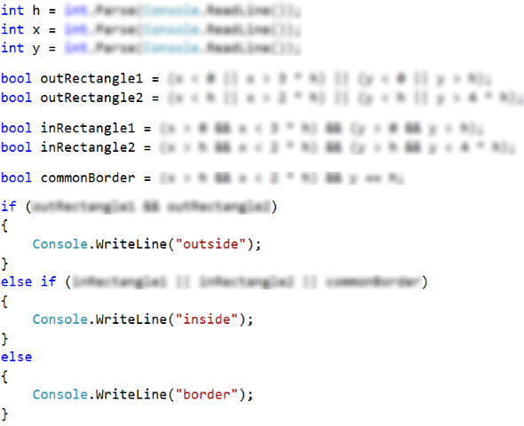

#### Testing in the Judge System

Test your solution here: <https://judge.softuni.org/Contests/Practice/Index/508#12>.

## Lab: * GUI (Desktop) Application – Point and Rectangle

In this mini book we learned how we can make **statements with non-trivial conditions**. Now let's apply this knowledge to create something interesting: a **desktop (GUI) app that visualizes a point in a rectangle**. This is a wonderful visualization of one of the tasks from the exercises.

The task that we have is to develop a graphical (**GUI**) application for **visualizing a point and a rectangle**. The application must look like identically to the following:

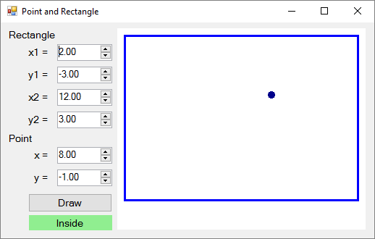

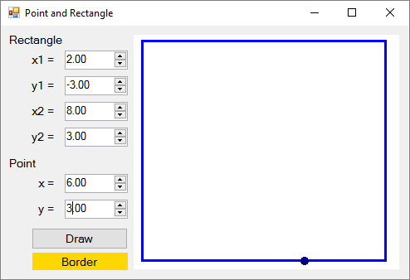

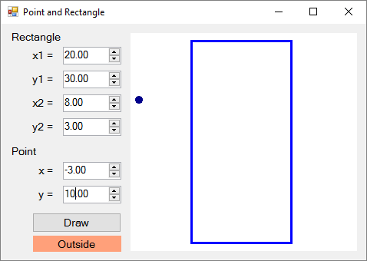

Using the controls on the left we set the coordinates of **two of the angles of the rectangle** (decimal numbers) and the coordinates of the **point**. The application **visualizes graphically** the rectangle and the point and prints whether the point is **inside** the rectangle (**Inside**), **outside** of it (**Outside**) or on one of its sides (**Border**). The application **moves and resizes** the coordinates of the rectangle and the point to be maximum large, but to fit the field for visualization in the right side of the application.

|  |  |
| --- | --- |
| https://csharp-book.softuni.org/assets/alert-icon.png | Attention: this application is significantly **more complex** than the previous graphical applications, which we have developed until now, because it requires using functions for drawing and non-trivial calculations for resizing and moving the rectangle and the point. Instructions for building the application step by step follow. |

### Creating a New C# Project and Adding Controls

We create a new project **Windows Forms Application** with a suitable name, for example “Point-and-Rectangle”:

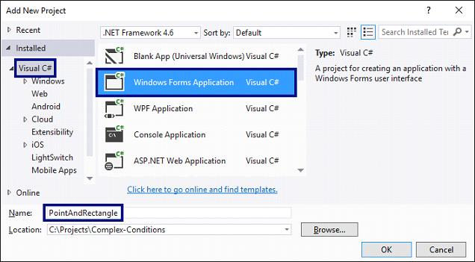

**We arrange the controls** inside the form, as it is shown in the figure below:

* 6 boxes for entering a number (**NumericUpDown**).
* Labels (**Label**) before each box for entering a number.
* A button (**Button**) for drawing the rectangle and the point.
* A text block for the result (**Label**).

We set the **sizes** and **properties** of the controls to look as close as the ones in the picture:

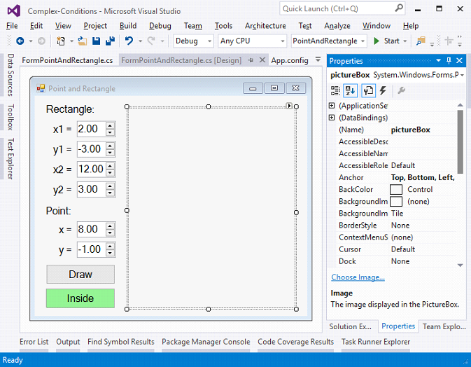

### Configuring the UI Controls

We set the following recommended settings of the controls:

* For **the main form (Form)** that contains all of the controls:
  + (name) = **FormPointAndRectangle**
  + **Text** = **Point and Rectangle**
  + **Font.Size** = **12**
  + **Size** = **700**, **410**
  + **MinimumSize** = **500**, **400**
  + **FormBorderStyle** = **FixedSingle**
* For **the fields for entering a number (NumericUpDown)**:
  + (name) = **numericUpDownX1**; **numericUpDownY1**; **numericUpDownX2**; **numericUpDownY2**; **numericUpDownX**; **numericUpDownY**
  + **Value** = **2**; **-3**; **12**; **3**; **8**; **-1**
  + **Minimum** = **-100000**
  + **Maximum** = **100000**
  + **DecimalPlaces** = **2**
* For **the button (Button)** for **visualization** of the rectangle and the point:
  + (name) = **buttonDraw**
  + **Text** = **Draw**
* For **the text block for the result (Label)**:
  + (name) = **labelLocation**
  + **AutoSize** = **false**
  + **BackColor** = **PaleGreen**
  + **TextAlign** = **MiddleCenter**
* For **the field with the draft (PictureBox)**:
  + (name) = **pictureBox**
  + **Anchor** = **Top**, **Bottom**, **Left**, **Right**

### Handling Events

We have to catch the following **events** to write the C# code that will be executed upon their occurrence:

* The event **Click** the button **buttonDraw** (it is called upon pressing the button).
* The event **ValueChanged** of the controls for entering numbers **numericUpDownX1**, **numericUpDownY1**, **numericUpDownX2**, **numericUpDownY2**, **numericUpDownX** and **numericUpDownY** (it is called upon changing the value in the control that enters a number).
* The event **Load** of the form **FormPointAndRectangle** (it is called upon starting the application, before the main form is shown on the display).
* The event **Resize** of the form **FormPointAndRectangle** (it is called upon changing the size of the main form).

All of the above-mentioned events will execute the same action – **Draw()**, which will visualize the rectangle and the point and show whether it's inside, outside or onto one of the sides. The code must look like this:

private void buttonDraw_Click(object sender, EventArgs e)

{

Draw();

}

private void FormPointAndRectangle_Load(object sender, EventArgs e)

{

Draw();

}

private void FormPointAndRectangle_Resize(object sender, EventArgs e)

{

Draw();

}

private void numericUpDownX1_ValueChanged(object sender, EventArgs e)

{

Draw();

}

/* TODO: implement in the same way event handlers

numericUpDownY1_ValueChanged,

numericUpDownX2_ValueChanged,

numericUpDownY2_ValueChanged,

numericUpDownX_ValueChanged and

numericUpDownY_ValueChanged */

private void Draw()

{

// TODO: implement this a bit later …

}

### Printing Point Position Compared to the Rectangle

Let's begin from the easier part: **printing the information about the point's position** (Inside, Outside or Border). The code must look like this:

private void Draw()

{

// Get the rectangle and point coordinates from the form

var x1 = this.numericUpDownX1.Value;

var y1 = this.numericUpDownY1.Value;

var x2 = this.numericUpDownX2.Value;

var y2 = this.numericUpDownY2.Value;

var x = this.numericUpDownX.Value;

var y = this.numericUpDownY.Value;

// Display the location of the point: Inside / Border / Outside

DisplayPointLocation(x1, y1, x2, y2, x, y);

}

private void DisplayPointLocation(

decimal x1, decimal y1, decimal x2, decimal y2, decimal x, decimal y)

{

var left = Math.Min(x1, x2);

var right = Math.Max(x1, x2);

var top = Math.Min(y1, y2);

var bottom = Math.Max(y1, y2);

if (x > left && x < right && …)

{

this.labelLocation.Text = "Inside";

this.labelLocation.BackColor = Color.LightGreen;

}

else if (… || y < top || y > bottom)

{

this.labelLocation.Text = "Outside";

this.labelLocation.BackColor = Color.LightSalmon;

}

else

{

this.labelLocation.Text = "Border";

this.labelLocation.BackColor = Color.Gold;

}

}

The code above takes the coordinates of the rectangle and the point and checks whether the point is inside, outside or on the borders of the rectangle. By visualizing the result, the color of the background of the text block that contains it is changed.

Think about how to **finish** the uncompleted (on purpose) conditions in the **if statements**! The code above **purposely doesn't compile**, because the purpose is to make you think about how and why it works and **finish on your own the missing parts**.

### Visualization of the Rectangle and the Point

What remains is to implement the most complex part: visualization of the rectangle and the point in the control **pictureBox** with resizing. We can help ourselves with **the code below**, which makes some calculations and draws a blue rectangle and a dark blue circle (the point) according to the coordinates given in the form. Unfortunately, the complexity of the code exceeds the material learned until the present moment and it is complicated to explain in detail exactly how it works. There are comments for orientation. This is the full version of the action **Draw()**:

private void Draw()

{

// Get the rectangle and point coordinates from the form

var x1 = this.numericUpDownX1.Value;

var y1 = this.numericUpDownY1.Value;

var x2 = this.numericUpDownX2.Value;

var y2 = this.numericUpDownY2.Value;

var x = this.numericUpDownX.Value;

var y = this.numericUpDownY.Value;

// Display the location of the point: Inside / Border / Outside

DisplayPointLocation(x1, y1, x2, y2, x, y);

// Calculate the scale factor (ratio) for the diagram holding the

// rectangle and point in order to fit them well in the picture box

var minX = Min(x1, x2, x);

var maxX = Max(x1, x2, x);

var minY = Min(y1, y2, y);

var maxY = Max(y1, y2, y);

var diagramWidth = maxX - minX;

var diagramHeight = maxY - minY;

var ratio = 1.0m;

var offset = 10;

if (diagramWidth != 0 && diagramHeight != 0)

{

var ratioX = (pictureBox.Width - 2 * offset - 1) / diagramWidth;

var ratioY = (pictureBox.Height - 2 * offset - 1) / diagramHeight;

ratio = Math.Min(ratioX, ratioY);

}

// Calculate the scaled rectangle coordinates

var rectLeft = offset + (int)Math.Round((Math.Min(x1, x2) - minX) * ratio);

var rectTop = offset + (int)Math.Round((Math.Min(y1, y2) - minY) * ratio);

var rectWidth = (int)Math.Round(Math.Abs(x2 - x1) * ratio);

var rectHeight = (int)Math.Round(Math.Abs(y2 - y1) * ratio);

var rect = new Rectangle(rectLeft, rectTop, rectWidth, rectHeight);

// Calculate the scaled point coordinates

var pointX = (int)Math.Round(offset + (x - minX) * ratio);

var pointY = (int)Math.Round(offset + (y - minY) * ratio);

var pointRect = new Rectangle(pointX - 2, pointY - 2, 5, 5);

// Draw the rectangle and point

pictureBox.Image = new Bitmap(pictureBox.Width, pictureBox.Height);

using (var g = Graphics.FromImage(pictureBox.Image))

{

// Draw diagram background (white area)

g.Clear(Color.White);

// Draw the rectangle (scaled to the picture box size)

var pen = new Pen(Color.Blue, 3);

g.DrawRectangle(pen, rect);

// Draw the point (scaled to the picture box size)

pen = new Pen(Color.DarkBlue, 5);

g.DrawEllipse(pen, pointRect);

}

}

private decimal Min(decimal val1, decimal val2, decimal val3)

{

return Math.Min(val1, Math.Min(val2, val3));

}

private decimal Max(decimal val1, decimal val2, decimal val3)

{

return Math.Max(val1, Math.Max(val2, val3));

}

In the code above we can see a lot of **conversion of types**, because different types of numbers are used (decimal numbers, real numbers and integers) and sometimes it is required to do conversion between them.

### Compiling and Testing the Application

In the end we **compile the code**. If there are errors, we eliminate them. The most probable **reason** for an error is **an inconsistent name of some of the controls** or if **writing the code in the wrong place**.

**We start the application** and **test** it. We enter different data to see whether it behaves correctly.

## What’s Next?

The “**Programming Basics**” series consists of publications for beginners in programming that covers the following topics:

1. First Steps in Programming – commands, programs, C#, Visual Studio,
2. Simple Calculations – variables, calculations, console input / output
3. Simple Conditions – conditional statements, the “if-else” construction
4. **More Complex Conditions – nested if-else, logical “and”, “or”, “not”**
5. Repetitions (Loops) – simple for-loops (repeat from 1 to n)
6. Nested Loops – nested loops and problem solving, drawing 2D figures
7. More Complex Loops – loops with a step, infinite loops with breaks
8. How to Become a Software Engineer?

The next topics are coming. Be patient!

## Sign-Up to Study in SoftUni

The easiest way to become a software engineer is to go through the “**Software University**” training program at SoftUni. Signup now for the **free Programming Basics training course**:

[**https://softuni.org/apply**](https://softuni.org/apply)

Join the SoftUni community and study programming for free in our **interactive training platform**. Get **live support** and mentoring from our trainers. Become a software developer now!